Conservation Officer
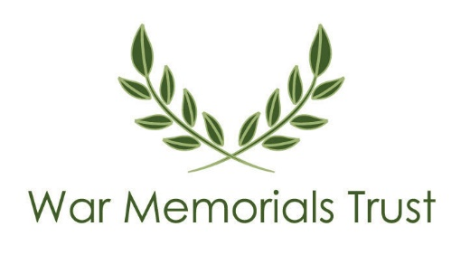
Monitoring Form

War Memorials Trust wants to meet the aims and commitments set out in its equality policy. This includes not discriminating under the Equality Act 2010 and building an accurate picture of the make-up of the workforce in encouraging equality and diversity.

The organisation needs your help and co-operation to enable it to do this but filling in this form is voluntary. The information provided will be kept confidential and will be used for monitoring purposes.

War Memorials Trust acknowledges its use of the Acas ‘Equality and diversity monitoring form template’ accessed from www.acas.org.uk/equality-and-diversity-monitoring-form-template on 22nd June 2022. If you have any questions about the form, contact us at info@warmemorials.org or 020 7834 0200.

Please return the completed form as outlined at www.warmemorials.org/vacancies.

Please do not edit this form or remove data. It is designed to enable you to write in the grey fields. The smaller grey check boxes can either be clicked or you may need to right click and select Properties to ‘check’. You can also print, complete by hand and scan a copy to return it.

This form will not be used during the application process but will be used for the purpose of recruitment monitoring and analysis. All information supplied will be held in the strictest confidence.

Post | 2023 Conservation Officer application
Age | 16-24 25-29 30-34 35-39 40-44 45-49  50-54 55-59 60-64 65+ Prefer not to say
Disability – Do you consider yourself to have a disability or health condition? | Yes No Prefer not to say  What is the effect or impact of your disability or health condition on your work?  The information in this form is for monitoring purposes only. If you believe you need a ‘reasonable adjustment’, then please discuss this with WMT.
What is your religion or belief? | Buddhist Christian Hindu Jewish Muslim Sikh  No religion or belief Prefer not to say Other religion or belief
Ethnicity | Ethnic origin is not about nationality, place of birth or citizenship. It is about the group to which you perceive you belong.  Asian or Asian British  Bangladeshi Chinese Indian Pakistani Prefer not to say  Any other Asian background  Black, African, Caribbean or Black British  African Caribbean Prefer not to say  Any other Black, African or Caribbean background  Mixed or Multiple ethnic groups  White and Black African White and Asian White and Black Caribbean Prefer not to say Any other Mixed or Multiple ethnic background  White  British English Northern Irish Scottish Welsh  Gypsy or Irish Traveller Irish Prefer not to say  Any other White background  Other ethnic group  Arab Prefer not to say Any other ethnic group
Sex / Gender | Please select the sex or gender option you identify as:  Female Male Intersex Non-binary Prefer not to say  Other – you can write in  Is the sex or gender you identify with the same as that registered at birth?  Yes No Prefer not to say
What is your sexual orientation? | Heterosexual Gay Lesbian Bisexual Asexual  Pansexual Undecided Prefer not to say  Other sexual orientation

