War memorial condition survey


This form is designed to help anyone wishing to undertake a condition survey of a war memorial to collect the relevant information. It is intended to be used alongside War Memorials Online, www.warmemorialsonline.org.uk. Ideally all information collected will be submitted via the condition update on the website making it is available to everyone. Alternatively, the form can be submitted by email or paper to War Memorials Trust for review by the Conservation Team but this will take longer to deal with.

Photographs
Please note it is essential that recent photographs of the war memorial are available for the Conservation Team to make an assessment of the war memorial’s condition and to take any necessary follow up action.

Photographs should show the whole memorial in its setting, each face, close-ups of areas of concern and the surrounding area. Photographs should illustrate the points raised in your condition survey.
Please see War Memorials Trust’s ‘Photographing war memorials’ helpsheet for further information and guidance on taking suitable photographs.

When submitting a condition update to War Memorials Online you can either add photographs to the main record (picture 1) or, if the memorial is in Fair, Poor or Very bad condition, photographs can be added as part of the condition update (picture 2). As around 70% of war memorials are in Good condition we do not request photographs as part of those condition updates as there is no concern about condition so photographs can go on the main record.
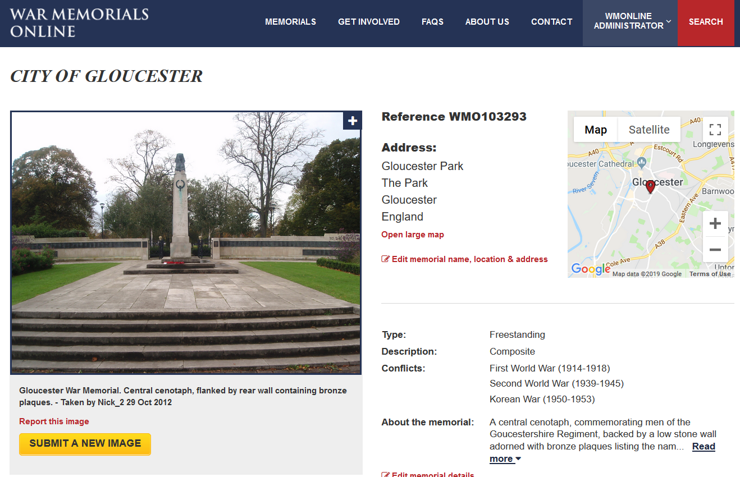
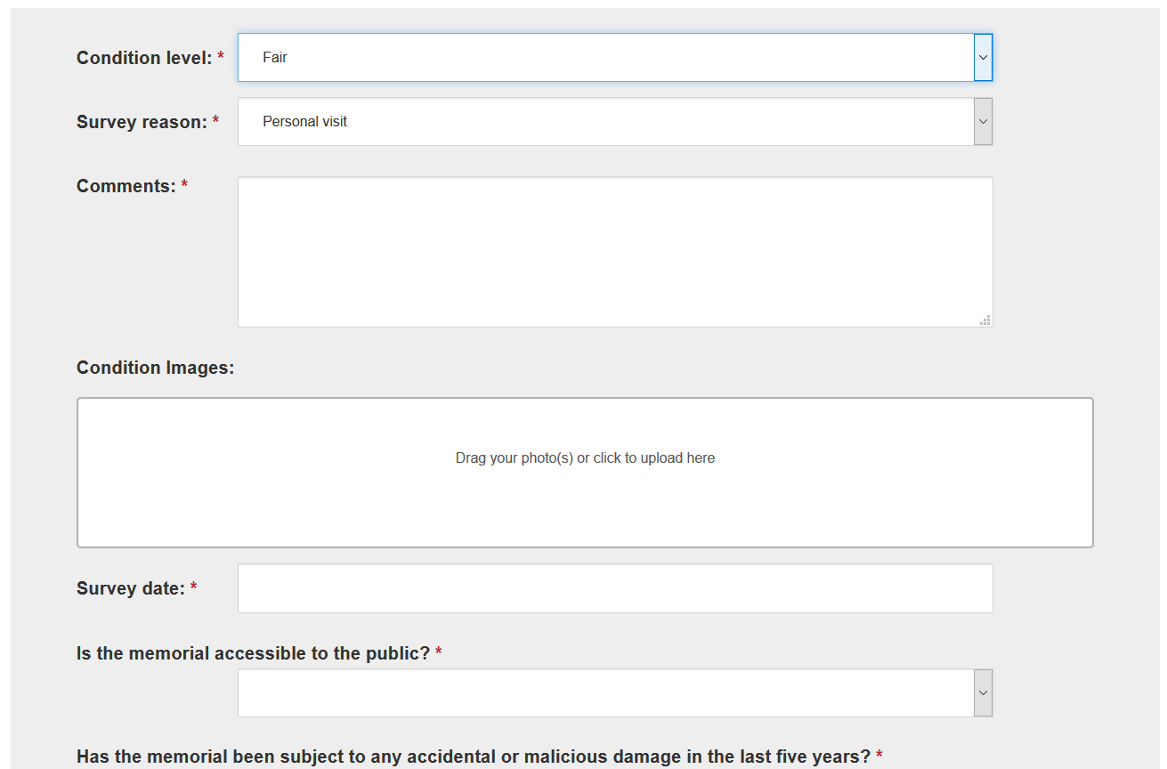

If you cannot upload to War Memorials Online and have to submit by email or post, please follow the guidelines below. As this places a greater administrative burden on the charity it may be several weeks before these can be processed so we do encourage you to use War Memorials Online.
- Email
  - Send as a jpeg files, preferably with a 300dpi resolution
  - Do not embed in a Word document or pdf – the quality is too low for assessment
  - Ensure emails are smaller than 8MB – this means you may have to send photographs over several emails or use a CD/USB
- Post
  - Send good quality colour images printed on photographic paper – avoid printing out too large as the quality deteriorates

Copyright details will be attributed to the person completing the condition survey unless otherwise stated.

Your contact details

Name: Organisation:
Address:
Email: Telephone number:

War memorial details

War Memorials Online reference number: WMO/
WMT reference number: WM
IWM War Memorials Register reference number:
Any other reference:

If this information on War Memorials Online is inaccurate please update it or let War Memorials Trust know if you cannot edit some details. You can do this by emailing conservation@warmemorials.org.

Name of memorial:

Address/location of memorial:

Materials: Stone (type ) Lettering: Incised (cut into memorial)
Metal Raised
Wood Painted
Brick Leaded
Glass Other
Other

Brief description of the war memorial to be added to the ‘About the memorial’ section: (type, decorative elements e.g. wheel cross with Celtic knot carving on three-stepped base)

Relevant background information: (e.g previous location, maintenance history, active planning applications)

Condition of the war memorial to be added to the Condition tab

What is the overall condition of the war memorial? Good Fair Poor Very bad

Reason for undertaking survey:

If other please specify:

Comments:

The following questions are designed to help you record information which you might want to include in the Comments section if the memorial is in Fair/Poor/Very bad condition. There is space below these questions for you to make more general notes.

Condition of metal: Good Fair Poor Very bad N/A

Does the war memorial appear structurally unstable (e.g. Cracks, leaning, movement)?
Yes No
If yes please provide details:

Is there any biological growth on the memorial (e.g. lichen, moss, algae)?
Yes No N/A

Are there any deep cracks on the memorial? Yes No N/A

Is there any missing mortar in joints (i.e. gaps between masonry)? Yes No N/A

Are there letters missing or are the inscriptions difficult to read? (Please refer to the ‘Inscriptions’ page of War Memorials Trust website for further guidance)
Yes No N/A

Further comments which may include additional detail on any areas above where yes was answered or note information of materials not covered above:

Date of survey:

Further Questions

Is the war memorial accessible to the public? Yes- always Yes- restricted times Yes- by appointment No Unknown

Has the memorial been subject to any accidental or malicious damage in the last five years? Yes No Unknown

Do you think the site is at significant risk of accidental or malicious damage in the next 2 years? Yes No Unknown

Are there any maintenance plans for this memorial available or known about? Maintenance plan available Maintenance undertaken None Unknown

Are there any known planning applications or issues related to this memorial?: Current planning application Previous planning application Unknown

Protection

This data relates to information you may be able to add to the Protection tab on War Memorials Online.

Is the memorial listed? (this can be identified by contacting local planning authority or the relevant heritage organisations website): Yes No Unknown

If yes at which grade?

Is the memorial within a conservation area (this can be checked with the local planning authority)? Yes No Unknown

If yes please provide the name of the conservation area:

Is the memorial recorded on a Local list or Historic environment record (this can be checked with the local planning authority)?
Yes No Unknown

If yes please provide the name of the list:

Next step

Please log into www.warmemorialsonline.org.uk, go to the relevant war memorial record and add this condition survey to the condition tab by clicking ‘Submit a Condition Update’. If you need any assistance with this, please contact the charity on the details below.

Ideally, all condition reports should be added directly to War Memorials Online so they are immediately available to everybody visiting the website as well as accessible to War Memorials Trust. If you are unable to add this information to War Memorials Online, please return the completed form and associated photographs to the details below.

War Memorials Trust 14 Buckingham Palace Road London SW1W 0QP
Telephone: conservation: 020 7233 7356 / 0300 123 0764
Email: conservation@warmemorials.org Website: www.warmemorials.org
Registered Charity Commission Number: 1062255 © War Memorials Trust, 2019

